STORED PROCEDURE

Stored procedure creating in mysql

In mysql there is a database called sakila , in that we have some stored procedures.

Right click on stored procedures ,there we can find “create stored procedure”.

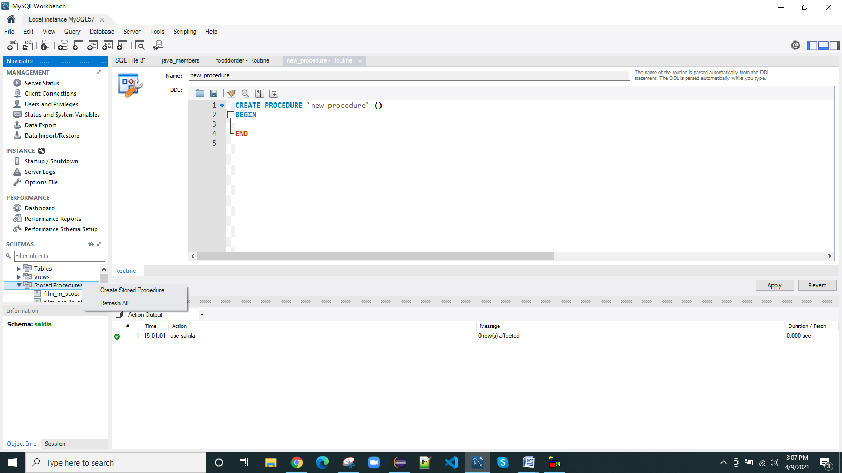

Click on Apply

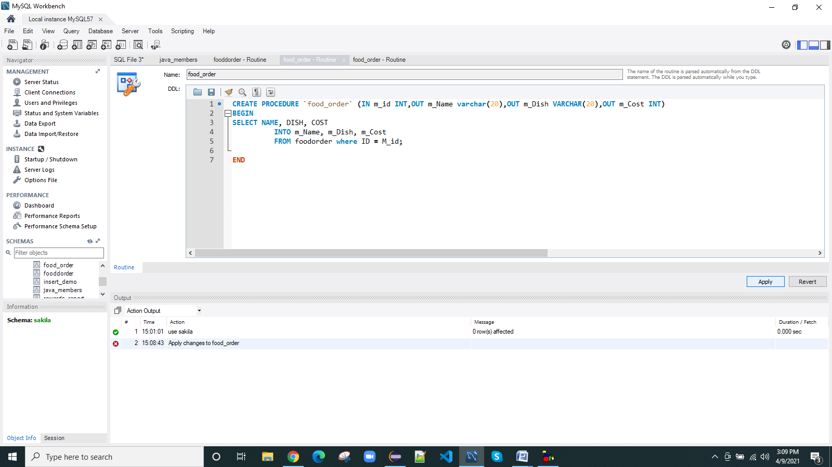

Again click on Apply

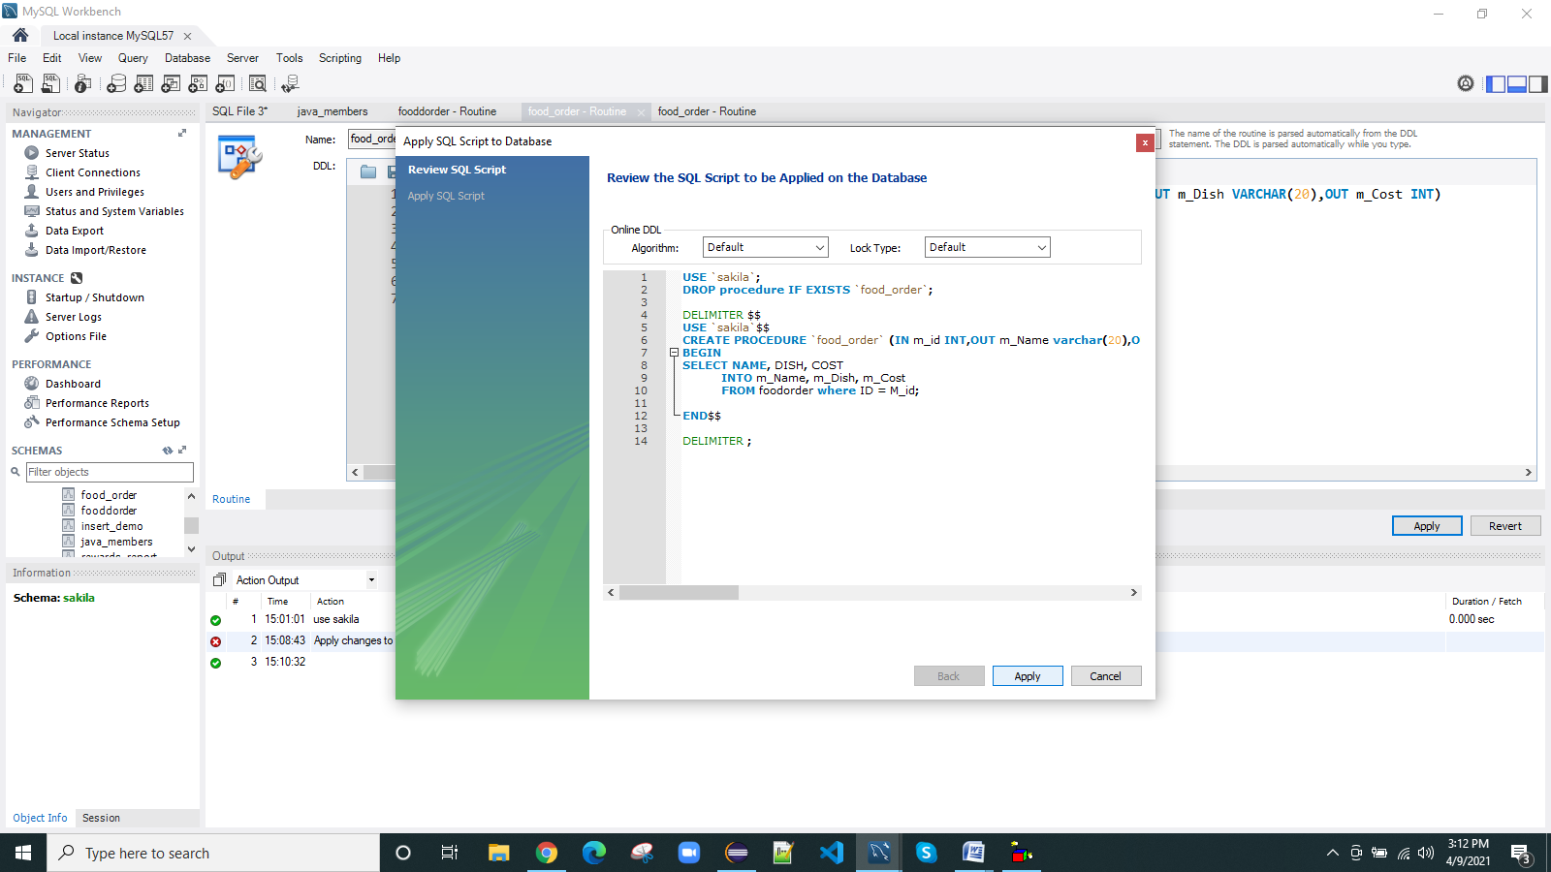

Now click on Finish

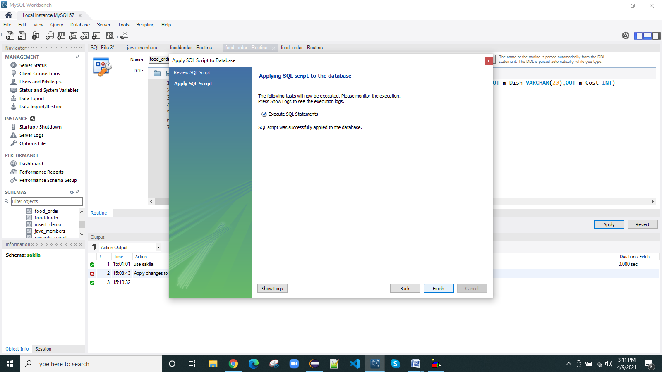

Finally stored procedure is created.

Stored procedure creating in mysql using java program

**import** java.sql.Connection;

**import** java.sql.DriverManager;

**import** java.sql.SQLException;

**import** java.sql.Statement;

**public** **class** CreateStoredProcedure {

**public** **static** **void** main(String[] args) {

**try** (Connection conn = DriverManager.*getConnection*("jdbc:mysql://localhost:3306/sakila?useSSL=false", "root",

"root");

Statement statement = conn.createStatement();) {

String queryCreate = "CREATE PROCEDURE food_order (IN m_id INT,OUT m_Name varchar(20),OUT m_Dish VARCHAR(20),OUT m_Cost INT) ";

queryCreate += "BEGIN ";

queryCreate += "SELECT NAME, DISH, COST INTO m_Name, m_Dish, m_Cost FROM foodorder where ID = M_id; ";

queryCreate += "END";

// then creates a new stored procedure

statement.execute(queryCreate);

statement.close();

System.***out***.println("Stored procedure created successfully!");

} **catch** (SQLException ex) {

ex.printStackTrace();

}

}

}

}

Output: Stored procedure created successfully!

Now you can see that in mysql, there is a stored procedure in the name of food_order

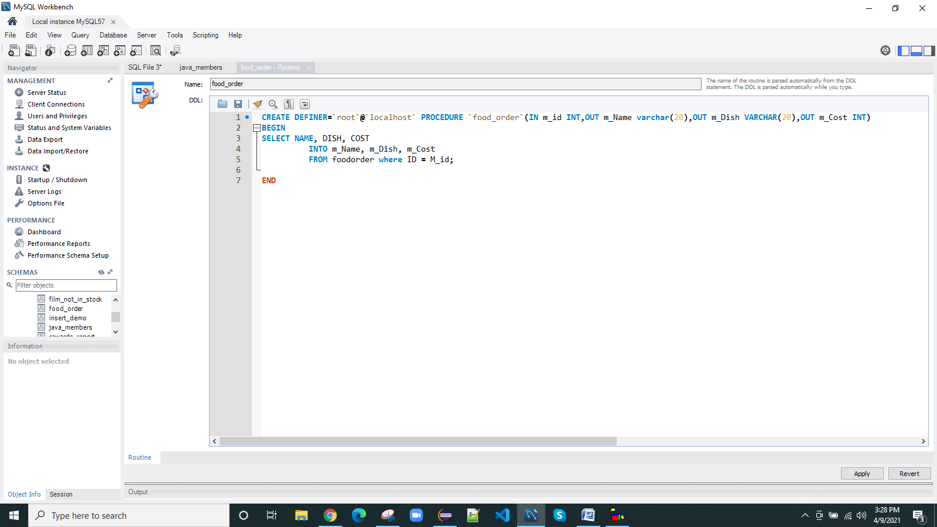

Calling a stored procedure using callable statement in java

From this data we are fetching

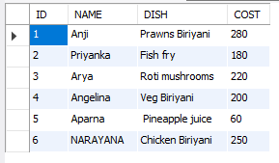

JAVA PROGRAM

**import** java.sql.DriverManager;

**import** java.sql.SQLException;

**import** java.sql.Types;

**import** com.mysql.jdbc.Connection;

**public** **class** CallableStatement {

**public** **static** **void** main(String args[]) **throws** SQLException, ClassNotFoundException {

// Registering the Drive

Class.forName("com.mysql.jdbc.Driver");

// Getting the connection

Connection con = (Connection) DriverManager.getConnection("jdbc:mysql://localhost:3306/sakila?useSSL=false","root", "root");

System.**out**.println("Connection established......");

// Preparing a CallableStatement to call a procedure

java.sql.CallableStatement cstmt = con.prepareCall("{call food_order(?, ? ,?, ? )}");

// Setting the value for the IN parameter

cstmt.setInt(1, 3);

// Registering the type of the OUT parameters

cstmt.registerOutParameter(2, Types.**VARCHAR**);

cstmt.registerOutParameter(3, Types.**VARCHAR**);

cstmt.registerOutParameter(4, Types.**INTEGER**);

// Executing the CallableStatement

cstmt.executeUpdate();

// Retrieving the values for name, dish and, cost

String name = cstmt.getString(2);

String dish = cstmt.getString(3);

**int** cost = cstmt.getInt(4);

System.**out**.println("Details of the customer with given id are: ");

// Displaying the values

System.**out**.println("Name: " + name);

System.**out**.println("Dish: " + dish);

System.**out**.println("Price: " + cost);

}

}

output

Connection established......

Details of the customer with given id are:

Name: Arya

Dish: Roti mushrooms

Price: 220